**EE 463 (Operating Systems)**

**Section: C3**

**Semester: Winter 2023**

Generalized Bash-Shell Scripts

|  |  |
| --- | --- |
| Name | ID# |
| Hayan Al-Machnouk | 1945954 |

**Course Teacher: Dr. Abdulghani M. Al-Qasimi**

**Department of Electrical and Computer Engineering**

**King Abdulaziz University, Jeddah, KSA**

Contents

**Part A (srm):** 3

**Delete trash** 3

**Recover trash to source directory** 4

**Recover trash to current directory** 5

**General case** 5

**Part B (phone):** 6

**Adding a record** 6

**Search a record** 6

**Replace a record** 7

**Delete a record** 7

**Part C (mmerge):** 8

**Template** 8

# **Part A (srm):**

Delete files into trash, and restores from trash

## **Delete trash**

**Recover trash to source directory**

## **Recover trash to current directory**

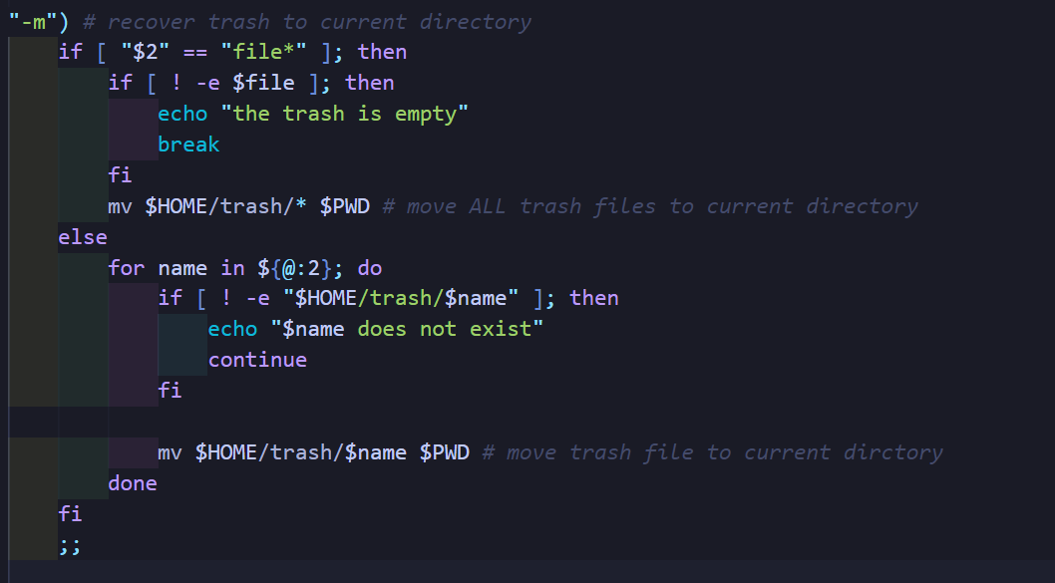

## **General case**

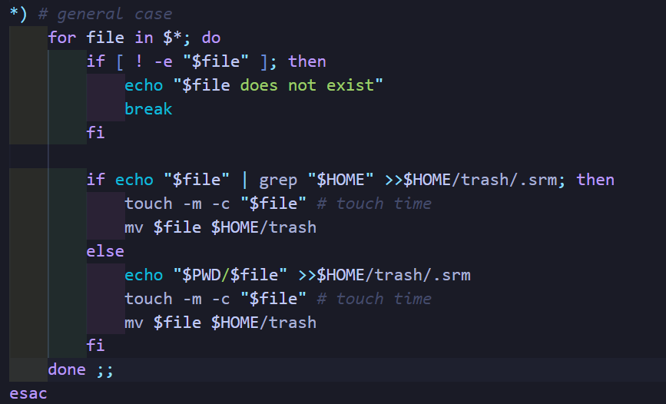

# **Part B (phone):**

Create and maintain phonebook

## **Adding a record**

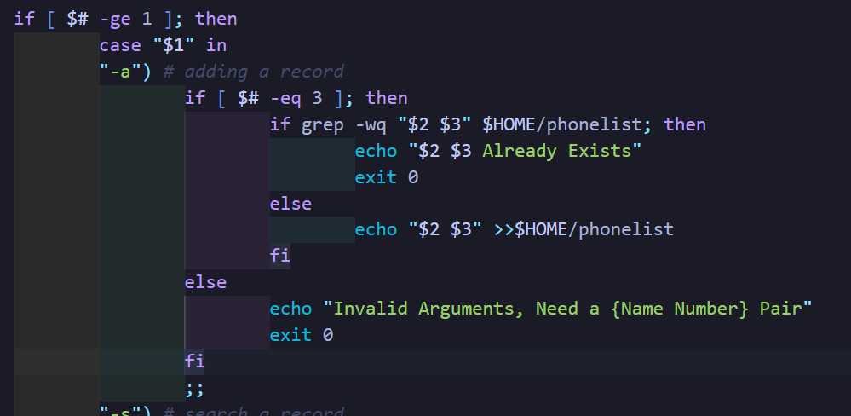

## **Search a record**

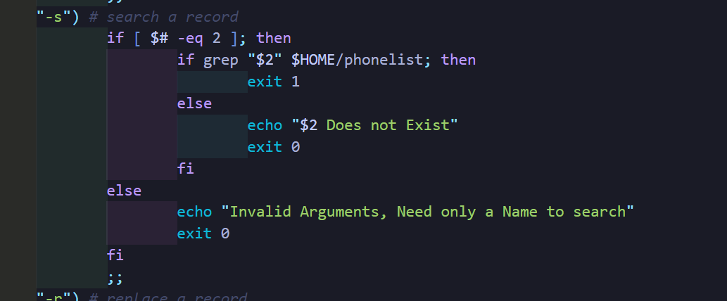

## **Replace a record**

**Delete a record**

# **Part C (mmerge):**

Fills a template message from a list of names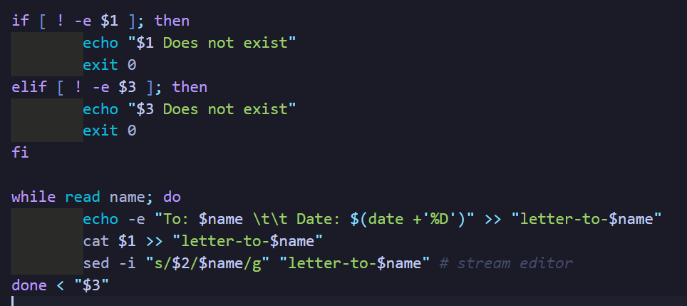

## **Template**

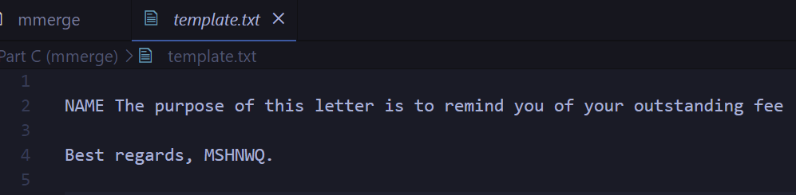

**Unit Tests for all the scripts can be found in the Tests Folder**